Task – 1
Identify the factors considering in selecting land, justify selection of land at your site
And describe the stage in site investigation

Introduction

The construction is huge project. It is depend on the availability of a suitable site. First of all we have to get the drawing of our plan from the architect. Then we want suitable land for it. The selected land soil textures have to be strong enough to build the building. Failure to select a suitable land can lead to exorbitant cost of the construction. Also it can lead to many other problems such as exhausted of construction safety of lives and properties and shown on. Before the site is selected for a project of importance. After that you will continue your work, we must need site investigation.

Factors considered in selecting the land:

When selecting a land many factors should be considered, and this can be done through a Site Investigation. A major factor to be considered in selecting a land is whether it is suitable for the budget and aim of the project. Another factor to be considered is to see if the land has an easy access.
The other major factors that should be taken in our site to consideration are:
- Location
- soil structure of the land
- Climate
- Natural hazards which could affect the building.
- Electricity
- Water supply
Other utilities should be considered as well, such as:
Telephone, Drainage, Sanitation.

Services that should be taken into account such as:
- Shopping
- Educational institutions
- Hospitals
- Postal service
- Police station
- Fire station.

Purpose of site investigation

- Settle on the suitability of land for the construction and find out the properties of soil.
- Determine the sequence, thickness of soil layers and load bearing capacity.
- Find out the classify soil and water table level.
- Focused the difficulties during construction and to take counteractive action in advance.

Site investigation

In a site has been selected for a new building project must be fully investigated. An inspection of the site and study of topographical features is often helpful in setting useful information about the soil and ground water conditions.

Site investigation can be dividing into two parts.
- Surface investigation
- Sup surface investigation or soil investigation.
Surface investigation
Following information is required for surface investigation

  - Topography of site
  - Geological maps
  - The service authority
  - Weathering condition
  - Material availability
  - Labour availability

Site organization depends on several factors
  - Type of Project:
  - Size:
  - Location
  - Project Duration: Quality of facilities depends on this.
  - Availability of Resources
  - Contractual Obligations:
  - Decentralization policy of the contractor
As our selected project’s aim is to build Residential Apartments, we should have considered selecting a land in a residential area. Our selected building’s land is situated near the BCAS. There by it has easy access to the main roads while noise pollution from traffic is minimized.

In considering natural disaster like Tsunami, the land of the selected building is in a safe distance from the sea coast. The building would give an enhanced architectural view and would also get better ventilation. This also has been considered in selecting the land.

One of the main factors which should be considered in selecting a land is the soil structure of the land. Results of the soil investigation report of selected land show that the soil of the land is weak. This is a negative point to the developers, who have taken much care in considering other factors in their site investigation. But this problem of weak soils has been solved by replacing the weak soils with well-compact granular soils.

As our selected site is in city area, the affect of the climate is negligible as there will not be a danger of flood as it is hot and dry weather in most part of the year in west coast of Sri Lanka.

When considering the utilities and facilities which are taken into account in selecting a land is very important. In this regard, our selected site is in an ideal location as it is a city area.
With regard to the supply of Electricity and Water, these are already available to the selected site as it was previously occupied by a two storey building.

THE STAGES IN SITE INVETIGATION

This is most important part in the construction field. If we want to construct the building first we want selected the land. The selected land has below the parts. That is safety our building.
- Land shape.
- Good soil condition.
- Ground water level.
- Near the building.
- Transportations.
- Electric supply.
- Water supply.
- Environment.
The particular area we want good soil condition because our building very heavy load therefore we want good bearing capacity of land. Designs of structures are directly affected by the underground conditions. As a structure is constructed, it subjects the foundation soil to considerable stresses therefore it is imperative, before construction, to study the soil and gain a thorough knowledge of the arrangement of its various strata existing below ground level, and the specific properties of each one of these.

Soil surveys finish information about the type, location, extent and profiles of these, and are essential for all new structures of importance. They are occasionally undertaken on existing structures as well, when there is some trouble like excessive settlement caused by the behavior of the soil existing at the site.

On engineering projects, soil surveys are useful both for design and during construction. Since it is difficult to change the character of soil existing at a site, the designs are based on the properties of the soil actually existing.

The characteristics of soil at a particular site can hardly be determined by consulting a handbook or from experience in adjoining sites. Each case required individual study.
Procedure of subsurface exploration.
A complete investigation includes the following:

- Nature of soil deposits consisting of its geology and information regarding flooding, excavations and filings in the recent past.
- Thickness and composition of each stratum of soil and its depth below ground level.
- Depth of ground water table below ground surface.
- The depth at which solid rock exists and its properties in relation to stability and bearing power.
- Engineering properties of soil and rock strata.
Reconnaissance investigation

It consists of an inspection of the site and the surrounding areas, and geologic study. If possible, aerial reconnaissance may be included.
Geologic study results in proper planning and interpretation of exploratory and detailed investigation. It primarily means determination of the nature of deposits under the site types of soils and rocks. Geologic history of the area may draw attention to changes in the original character of deposits like faulting, gull eying and flooding. Defects like cracks, fissures and caves may be suspected. Geologic study also reveals where the area is seismic to a degree likely to affect the stability of the structure, in which case either the site may be changed or design altered suitably.

Boring and sampling
This is simple and primitive equipment and collects a highly disturbed sample in a loose state. The auger may be hand driven or motor driven, the later being capable of drilling holes in some soils up to a depth of 30m. In a very short time. However, the sample obtained only contains a blending of material from various depths, and the various layers of soils cannot be identified from the same.
From these considerations, the augers are utilized only where the drilling is not required deeper than 4m.in exploration for railway tracks, roads and airports, although even with hand operated augers, drilling up to 30m. Is possible.

Conclusion

According to the Soil Investigation Report of the selected site, either Raft foundation or Pile foundation was recommended. If only the Pile foundation was recommended, the developers wouldn’t have selected the land because of the high expenses involved. Therefore developers have selected the land because of Raft foundation was recommended as the first option.

Task-02
Explain the classification of the soil with respect to the borehole test results and describe the soil investigation method carried out your site.

Different types of the soil
- Clay
Clay is a naturally occurring material composed primarily of fine-grained minerals, which show plasticity through a variable range of water content, and which can be hardened when dried or fired. Clay deposits are mostly composed of clay minerals (phyllosilicate minerals), minerals which impart plasticity and harden when fired or dried, and variable amounts of water trapped in the mineral structure by polar attraction. Organic materials which do not impart plasticity may also be a part of clay deposits.
- Silt
Silt is soil or rock derived granular material of a specific grain size. Silt may occur as a soil or alternatively as suspended sediment in a water column of any surface water body. It may also exist as deposition soil at the bottom of a water body.
- Sand
Sand is a naturally occurring granular material composed of finely divided rock and mineral particles. Refer fig.2.1
- Peat
Peat is an accumulation of partially decayed vegetation matter. Peat forms in wetlands or peat lands. See fig.2.2

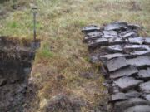
Fig-2.1. Sand Fig-2.2. Peat

These are the classification of soil in our site from surface to depth.

Soil Classification BH-01 Depth (m)

- Fine grained sand with silts-loose 0.00 – 2.45
Yellowish reddish L/Brown in colour

- Fine grained sand with the traced of 2.45 – 3.45
Medium grained sand-medium dense
Yellowish reddish brown in colour

- Fine grained sand with the traced of 3.45 – 7.50
Medium grained sand-medium dense
Grayish white in colour in colour

- Fine grained sand with the traced of 7.50 – 7.95
Medium grained sand-medium dense
Grayish white in colour in colour

- Fine grained sand with the traced of 9.00 – 9.45
Medium grained sand-medium dense
Yellowish reddish brown in colour

- Fine medium coarse grained sand very 9.45 – 15.45
Dense yellowish white in colour

- Borehole terminated at the depth of 15.50m depth

Soil Investigation.

The client proposes to construct a six storeyed apartment building at No.33, E.S.FERNANDO MAWATHA.COLOMBO-6. ENGINEERING SOIL LABORATORIES (PVT.) LTD was authorized to carry out geotechnical site investigation and to prepare a geotechnical report together with foundation recommendation.
The objective of this soil investigation was to evaluate the engineering characteristics of sub-surface soil profile in order to determine the bearing capacities and to decide on suitable safe founding options for the proposed structure.
Field investigation consisted of advancing of 2 boreholes with soil sampling and relevant in-situ tests.The soil report presents the results of the soil investigation carried out for the said project.

The sketch plans showing the approximate exploratory boring locations are presented following the text of this report in fig-1. Borehole logs are presented in the annexure.

Field Investigation
Field Investigation consisted of drilling of 2 Nos. boreholes down to bedrock level. The boreholes locations are denoted as BH-01 and BH-02 in the annexed Sketch plan figure-1.

Mobilization of Drilling Rig, Equipment and personal were carried out on 25th September 2008. All drilling and field test procedures were carried out in compliance with BS 5930 and BS 1377 standards.

Drilling Investigation Methodology

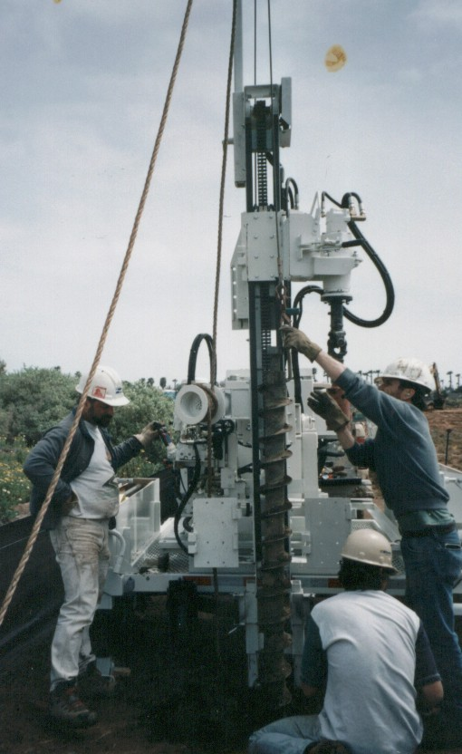

Fig-2.3 Method of Drilling
Soil testing

A soil test is the analysis of a soil sample to determine nutrient content, composition and other characteristics. Tests are usually performed with a soil test kit to measure fertility and indicated deficiencies that need to be remedied. Soil testing is often performed by commercial labs that offer an extensive array of specific tests. Less comprehensive do it yourselves kits are also available, usually with test for three important plant nutrients-nitrogen(N) phosphorus(P) and potassium(k) and for soil acidity(pH). Lab test are more accurate though both types are useful. The quality of the original soil sample plays a key role in determining the practical value of test result. Soil characteristics can vary significantly from one spot to another, even in a small garden or field. Sample depth is also an important factor. And the presence of variant nutrients and other soil components varies during the year, so sample timing may also be important. Mixing soil from several locations to create an “average” sample is a common procedure. All if these considerations affect the interpretation of test results.

Purpose of soil investigation

- Determine the suitability of the site for the proposed project.
- Determine an adequate and economic foundation design.
- Determine the difficulties which may arise during the construction process and period.
- Determine the occurrence or all change in subsoil condition

Black cotton soil

Black cotton soils are found extensively in Asia, Australia and South America. They are very fertile, especially for cotton crops. They undergo large volume changes with change in moisture content, making them unsuitable for the foundations of structures. They have a very high proportion of montmorillonite clay.

Method of improving the bearing capacity of soils

Following method are generally adopted to improve the bearing capacity of soil

- Increasing the depth of the footing is the simplest method of increasing the bearing capacity. This method is restricting to the sites where the subsoil water level is much below and deep excavation do not increasing the cost of the foundations disproportionately.

- Drainage is a well known method to improve the Bering capacity of certain soil. Drains are laid in trenches just at the footing base. The subsoil water thus collected is drained out through a system of pipe drains provide outside the external wall of the building.

- By blending granular material, like sand gravel or crushed stone into the natural soil by ramming. The layer of soil thus formed is much stronger and is of improved bearing capacity.
Consolidation

Conclusion

Soil testing is an important part in site investigation because it describes the bearing capacity of the soil, the placement of the layers, the depth of the layers, permeability of the soil and water table level. These are the most important factors should be considered before designing the building. It involves in choosing the foundation also.
By doing this task I came to know, how to read or understand the borehole log and its technical words and the machineries, methods used relating soil investigation.

Task 03
Describe different type of foundation.
Foundation
Introduction
- Every building consists of two basic components: the super- structure and substructure or foundations. The super- structure is usually that part of the building which is above ground, and which serves the purpose of its intended use. The substructure or foundation is the lower portion of the building, usually located below ground level, which transmits the load of the super structure to the sub soil. A foundation is therefore that part of the structure which is in direct contact with the ground to which the loads are transmitted.
- The basic function of a foundation is to transmit the dead loads, super imposed loads and wind loads from a building to the soil on which the building rests, in such a way that (a) settlements are within permissibly limits, without causing crakes in the super structure, and (b) the soil does not fail. When loads are transmitted. To the sub soil, it settles. If this settlement is slight and uniform throughout, no damage will be caused to the building.
- The foundation is thus, the most important part of a building. Since it remains below the ground level, the signs of failure of foundation are not noticeable fill it has already affected the building.
Function of foundation
- Reducing of load intensity:-
Foundations distribute the load of the super structure, to larger area. So that the intensity of the load at its base not exceed the safe bearing capacity of the sub soil in the case the case deep foundation, it transmits the super imposed loads to the sub soil both though side friction as well as through end bearing.

- Even distribution of load:-
Foundation distribute the non- uniform load of the super structure evenly to be sub soil
- Provision of level surface:-
Foundation provide leveled and hard surface over which the super structure can be built.
- Lateral stability:-
It anchors the super structure to the ground thus imparting lateral stability to the super structure the stability of the building, against sliding and over turning, due to horizontal force (such as wind earth quake) is increased due to foundations.
- Safety against undermining:-
It provides the structure safety against undermining or scouring due to burrowing animals and flood water.
- Protection against soil movements:-
Special foundation measures prevents or minimizes the distress (or cracks) in the super structure, due to expansion or contraction of the sub soil because moisture movement in some problematic soil.

Foundation may be broadly classified as two types
- Shallow foundation
- Deep foundation

Shallow foundation
The shallow foundation is used for founding depth is less than the width of the footing and less than 3m. Shallow foundation is used when surface soils are sufficiently strong and stiff to support the dead loads & imposed loads.

The following types are including this foundation.
- Pad foundation
- Strip foundation
- Raft foundation
- Stepped foundation

Deep foundation
This foundation is used to construct low bearing capacity soil in upper soil layers. The founding too deeply below the finished ground surface their base bearing capacity to be affected by surface conditions. This is usually at depth grater than 3m below ground level.
The following types are including this foundation.
- Pile foundation
- Pier foundation

Pad foundation

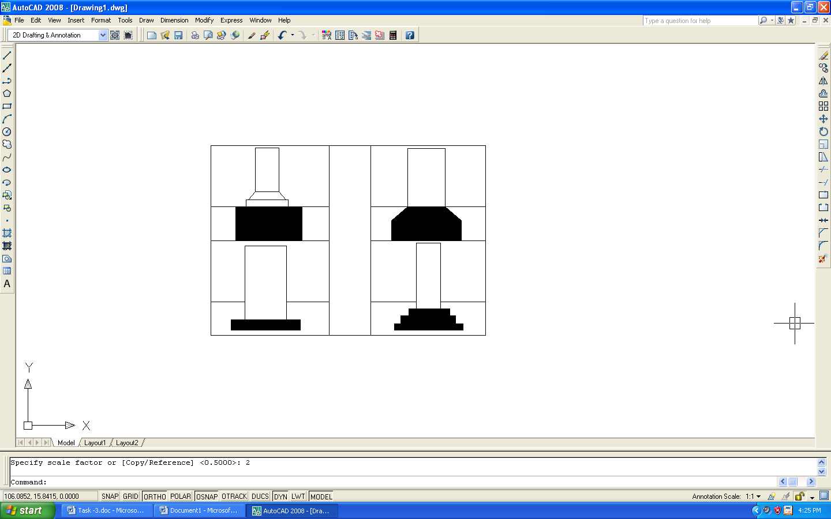
Figure 3 -Pad foundation
These are isolated foundation. This is required to support reinforcement concrete columns or steel pillars or detached brick masonry piers. When designing a column foundation, the area of square foundation is taken by dividing the total column load by the safe bearing capacity of the soil.
The reinforcing bars are mild steel round bars or tor steel bars equally spaced in both direction. The concrete cover to reinforcement should be at least 40mm. In order to achieve a clean bed for the main concrete it is usually to put a 50mm to 75mm thick blind concrete on the bottom of the excavation.
The lean concrete mix of 1:3:6(40mm). The reinforcement cement concrete mix is 1:2:4(20mm).
Materials used for this foundation
- Cement
- Course aggregates
- Fine aggregates
- Water
- Mild steel
- Tor steel
- Binding wire
- Cover slab ( 1:2 cement mortar)
- Form work books

The reinforce arrangement of the pad foundation.
Figure 4 – Cross section of pad foundation
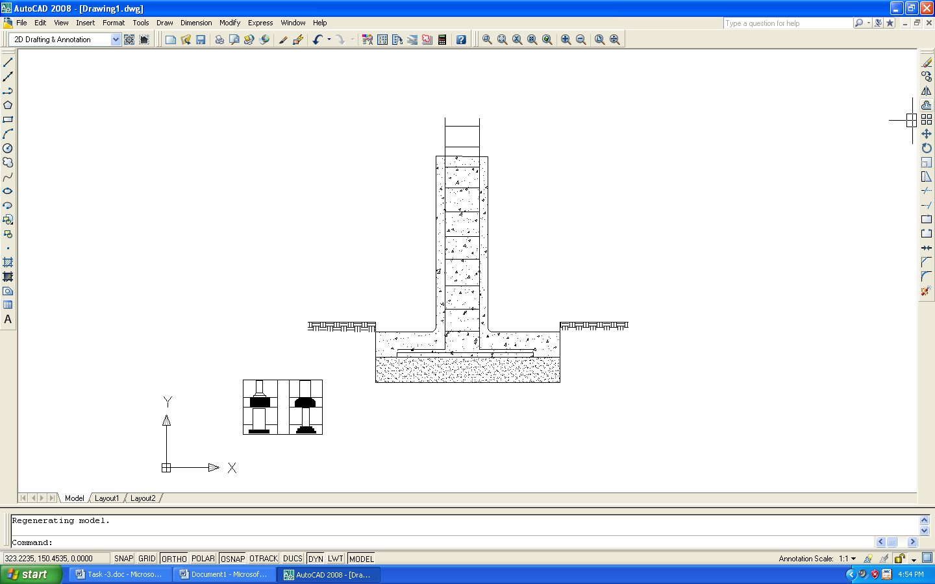

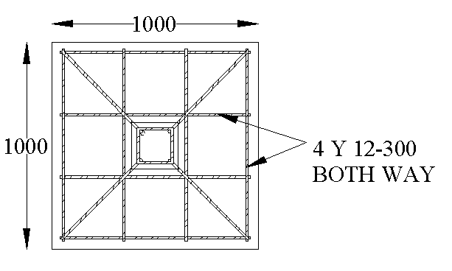

Plan of pad foundation

These foundations are used to column in single stores building.

Strip foundation
These foundations are normally used to partition walls and single stores load bearing walls.
This foundation may consist of
- A concrete bead only, also called strip footing.
- One or more courses of stone work or rubble masonry work, wider than the wall they support, are also known as footing.
- A concrete bed together with footing.

The strip foundation is one which provides a continuous longitudinal bearing to a wall or pier.

The footing placed in some methods
- Plain concrete bed
- Reinforcement concrete bed
- Brick footing
- Random rubble foundation

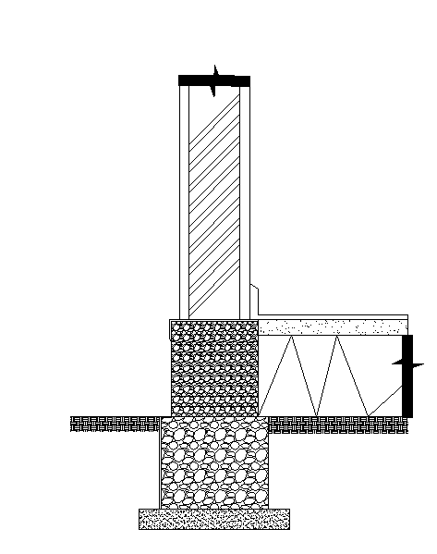
Random rubble foundation

F igure 6 – Random rubble foundation

Concrete footing foundation

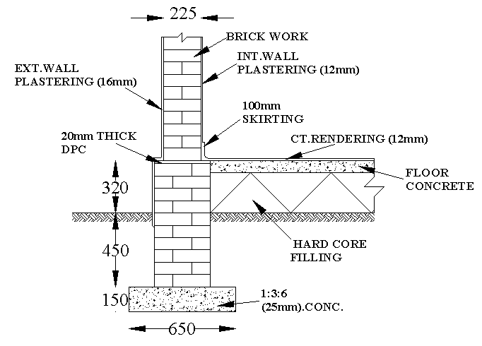
Figure 7– Concrete footing foundation

Brick footing foundation
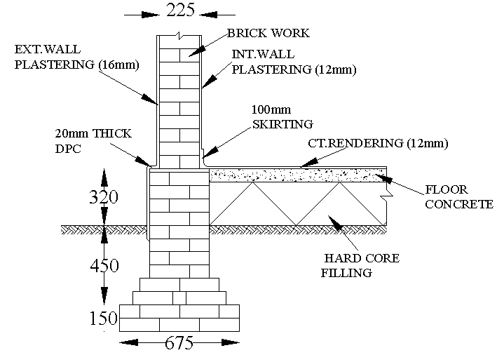

Figure 08– Brick footing foundation

Stepped foundation
This foundation is used in different level surface. The mountain areas we placed this foundation.
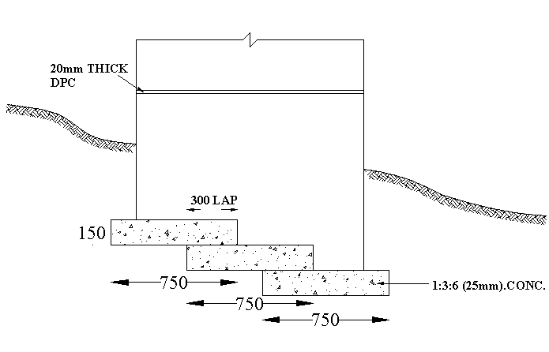

Figure 9 – Stepped foundation

Reinforce footing foundation
The reinforcement bars are used in these foundations footings. This reinforcement bars is give to more strength to foundation.
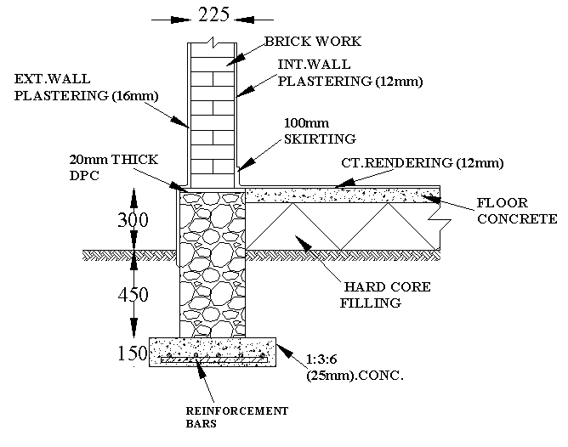

Figure 10 – Reinforce footing foundation

Raft foundation
The raft is a combined footing foundation. That is covered entire area of structure and supports all the walls, columns and slab. When allowable soil pressure is low or the building loads are very high the raft foundation is used. Raft foundation is also needed to reduce settlement on highly compressive soils, by making the weight of the structure and raft approximately equal to the weight of the soil excavated.
Some function of raft foundation
- Raft foundations have the advantage of reducing differential settlements as the concrete slab resists differential movements between loading positions.

- They are often needed on soft or loose soils with low bearing capacity as they can spread the loads over a larger area.

- Rafts are designed as reinforced concrete flat slab.

- The weight of the raft is not considered in the structural design because it is assumed to be carried directly by the subsoil.
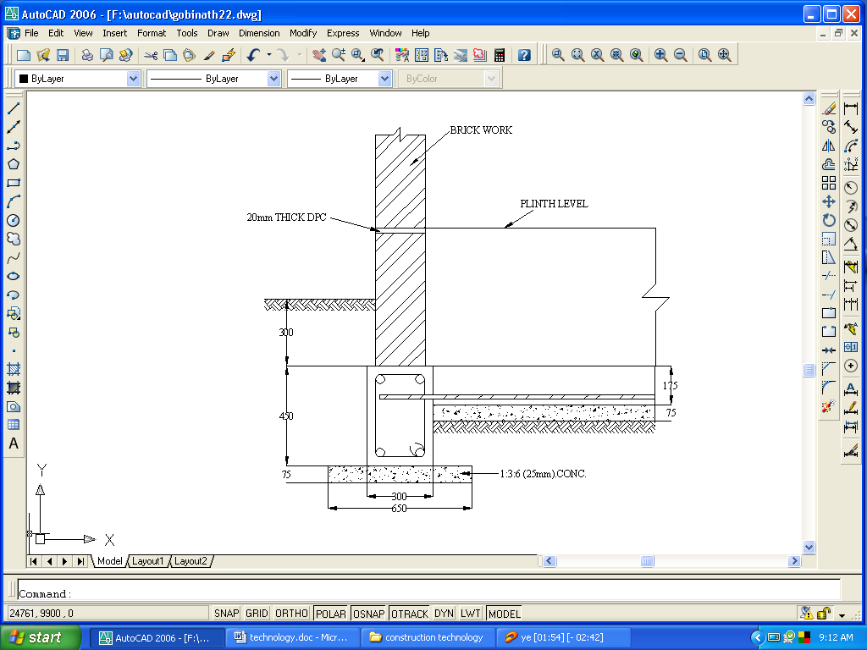

Figure 11 – Raft foundation

Common type of the raft foundation

- Flat plate type
- Flat plate thickened under columns
- Flat plate with pedestals
- Tow way beam and slab type
- Cellular construction
- Basement wall as rigid frame

The reinforcement arrangement of raft foundation

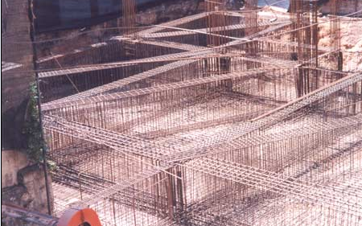

Figure 12– Reinforcement arrangement of raft foundation

Raft foundation beam
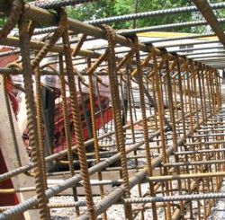

Figure 13 – Raft foundation beam

Pile foundation
The pile foundation is a one type of deep foundation. This is may be define as a column support type of foundation which may be cast in situ or precast. This type of construction is adopted when the loose soil extends to a grate depth. The load of the structure is transmitted by the piles to the hard stratum below or it is resisted by the friction developed on the side of piles.
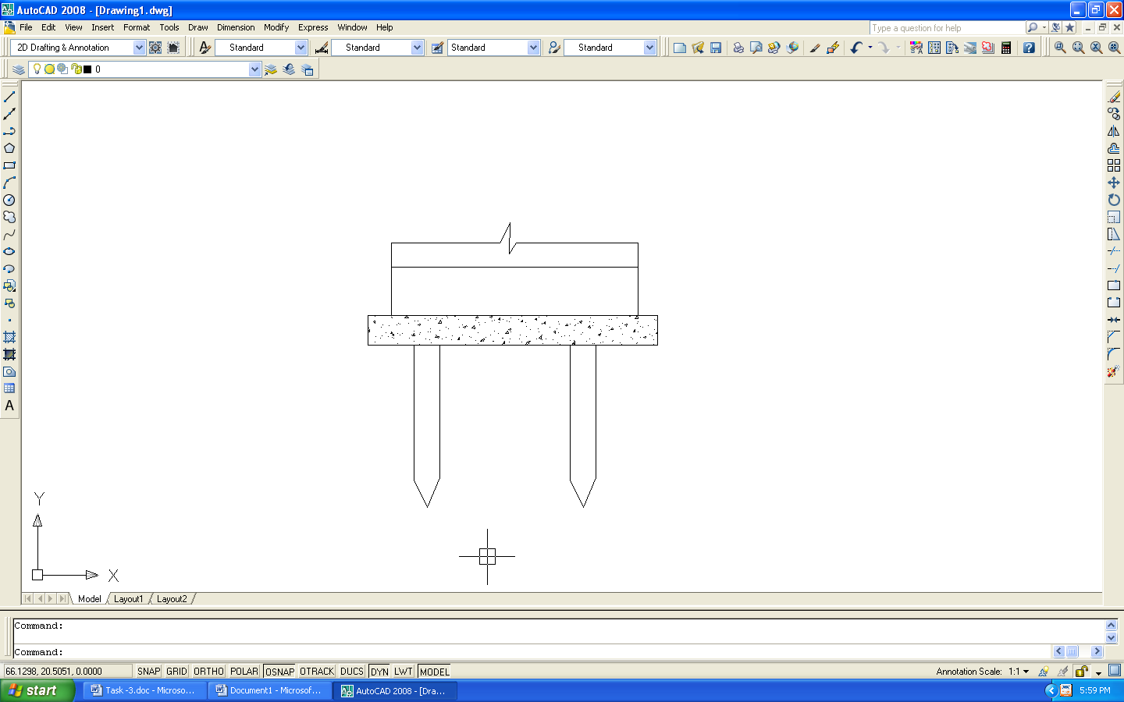
Figure14 -Pile foundation

Type of piles
- Classification based on function
  - End bearing piles
  - Friction piles
  - Compaction piles
  - Tension piles or uplift piles
  - Anchor piles
  - Fender piles
  - Batter piles
  - Sheet piles

- Classification based on materials and composition
- Concrete piles
  - Precast piles
  - Cast in situ piles
- Timber piles
- Steel piles
- H- piles
- Pipe piles
- Sheet piles
- Composite piles
  - Concrete and timber
  - Concrete and steel

Materials used in piles and pile driving
- Cement
- Sand
- Course aggregate
- Tor steel
- Mild steel
- Hammering machine
- Higher strength concrete
- Skilled labors

Reinforcement method of pile foundation
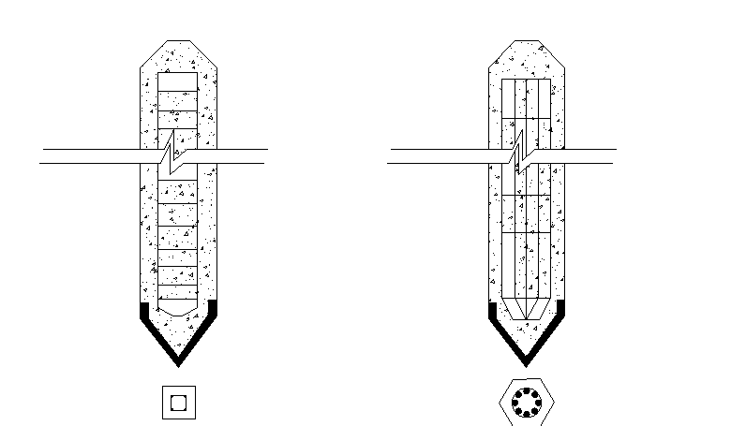
Figure 16 – Reinforcement method of pile foundation

Advantage of pre concrete piles

- The piles are manufacturing in the factory
- High strength concrete is used and make good quality control
- The position of reinforcement in the pile is nit liable to be disturbed
- The casting defect can be easily discovered
- Save the construction period or time

Task-04
Identify the discuss various factors considered in selecting a foundation type and justify the selected type of foundation for the building selected.

Objective of foundation

Foundation is provided for the following purpose;

- To distribute the load of structure, on large area, so that the intensity of load does not exceed the safe bearing capacity of the underlying soil.

- To distribute the load on underlying soil evenly and thus to prevent unequal settlement of the foundation.

- To provide a level and hard surface for the super structure to be build over it.

- To increase the stability of the structure as a hole, against sliding, overturning or other disturbing forces like wind, rain etc.

- To prevent lateral movement of the supporting material, so that the safetyof the structure is not endangered.

Essential requirements of a good foundation

Foundations should be constructed to satisfy the following requirements

- The foundations shall be constructed to sustain the dead and imposed loads and transmit these to the sub soil in such a way that pressure on it will not cause settlement which would impair the stability of the building or adjoining structures.

- Foundation base should be rigid so that differential settlements are minimized, specially for the case when super imposed loads are not evenly distributed.

- Foundations should be taken sufficiently deep to guard the building against damaged or distress caused by swelling or shrinkage of the sub soil.

- Foundations should be so located that its performance may not be affected due to any unexpected future influence.

Design and choice of a foundation

- The following factors to be considered in choice and design of a foundation,
- The bearing capacity of subsoil and its nature
  - The maximum allowable load per unit area is called as bearing capacity. It is depend on
  - Type of soil
  - Density, shearing strength and other physical properties of soil
  - Water table level

- Structural load of building
- Construction cost
- Speed of construction
- Weather conditions
- Physical properties of foundation(Size, Shape, Type)
- Depth below ground level
- Continuation of soil strata
- Construction problems
- The factor that ratio of Load / Bearing capacity of soil
- Shearing stress and Vertical pressure

Selection of most suitable foundation

- Pile foundation is not suitable for this building. For the following reasons

- There will be more skilled laborers needed.
- Also huge machineries widely needed.
- Erecting piles may cause damages on the surrounding buildings. And pay compensation for them.
- All these above will increase the overall cost of construction. All clients expect low cost construction. As; pile foundation is not suitable for this dwelling.

- Also, pad foundation is not suitable for this building. For the following reasons

  - It’s not suitable for filled areas. In this case around half of this land is covered by peat soil. It is removed and refilled. So, pad is not suitable.
  - This land has silty clay soil type. It is a very loose soil. For silty clay it is not suitable.

- So, raft foundation is the most suitable for this kind of building. For the following reasons

- Raft is most suitable for silty clay type soil.
- Suitable for this filled area
- Sometimes columns may be closely spaced.
- More economical than pile foundation
- Safe than pile foundation for environment.

Conclusion
From this task, I got a lot of knowledge in
- Types of foundations and specially about raft foundation
- In selecting the suitable type of foundation according to given reason
- Finally, construction methods of raft foundation.

Task-05
Describe the method of excavation and the associated temporary work carried out at your site.

- We have to do excavation for some of reasons mentioned below,

- To remove unsuitable material such as peat, black cotton soil and other filled materials.
- To level the uneven ground.
- To achieve the required level.
- To construct the superstructure.
- To construct the underground structure like basement.

- There are two types of excavation methods

- Manual
- Machinery

- The selection of excavation method depends on the following factors

- Nature of the sub soil
- Purpose of the excavation
- Presence of the ground water
- Availability of the plant and the site limitation
- Location of the excavation
- Cost

- We can categorize the excavation in three categories, by considering the deep of the excavation.

- Shallow - Up to 1.5 m deep.
- Medium – 1.5 m to 3 m deep
- Deep – above 3 m deep

Types of excavation

There are several types of excavation used in the building process, the type and method depending on the amount of ground to be excavated.

- Soil strip
- Reduced level excavation
- Bulk excavation
- Trench excavation
- Hole or Pit excavation

Soil strip

After vegetable soil is removed excavation is takes place. The process is to strip the surface of the ground of its topsoil covering, and this may be achieved by the use of certain types of machinery bulldozer pushing the topsoil layer to a convenient stockpile position a short distance away;

- By a scraper ‘paring off’ the top layer, transporting it, and depositing it at a stockpile position some distance away on large site

- By a drag line scraping of the top layer and either depositing it at convenient stockpile or loading the material into wagons for transport off site

- By back actor operating in a similar manner to the drag line

- By the mechanical shovel (track- or wheel – driven) operating in a similar manner to the drag line

- By a skimmer – a machine specifically designed for this type of work

Fig.5.1 Soil strip excavation

Reduced level excavation

The ground which lies between the topsoil and earth’s crust is known as the subsoil ands comprises particles of weathered rock of various shapes and sizes. It is usually necessary to provide a level surface from which construction may take place, and this level may be lower than the top of the subsoil. In such cases, excavation into the subsoil is required to reduce the level of the ground. The volume of subsoil to be excavated, together with the nature of the material, will determine the type of machine and methods to be used.

On sloping site it may be necessary to cut in to the banking on one side of the proposed building, while filling with suitable material on the other side, in order to achieve the level working surface or formation level.

Fig.5.2 Reduced level excavation

Bulk excavation

Where large volumes of subsoil are required to be excavated in order to reach the formation level, the excavation is known as bulk excavation. This type of excavation may be reduce levels or to provide basement areas. In addition to the plant already mentioned, a face shovel my also be used for this type of work.

Fig.5.3 Bulk excavation

Trench excavation

Having excavated or filled to a formation level, it is frequently necessary to excavate trenches to a lower level. In these trenches the foundations of the building are constructed. Trenches are also required outside the building for the laying of pipes and other services.

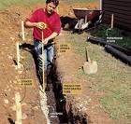

Fig.5.4 & 5.5 Trench excavations

Hole or pit excavation

The design of the substructure may require holes or pits to be excavated. In the case of circular holes, hand mechanically driven augers or drills are used. Pits, being small shallow or rectangular holes, may be excavated mechanically or by hand.

The method of excavation carried out at the selected site.
To answer this task, I selected the ongoing site which is situated at No.33, E.S FERNANDO MAWATHA COLOMBO-6. It is a five storied apartment building.

Bulk excavation

- First of all they selected the appropriate excavation method for the proposed foundation
- Here, the proposed foundation was raft, because of that they selected the bulk excavation

- Plan the work
- They planned to do the excavation and construction part by part, Because of it is somewhat easy.

- Site clearance
- They removed the un wanted trees, bushes and tree roots on the surface

- Identify and mark the boundary line of the area to be excavated
- They identified the position through the proper surveying using theodalite and chain surveying.

- Start the excavation
- They started the excavation using JCB excavator.

- Shoring
- While, they excavate they did they proper shoring to the land.( shoring is briefly discussed on the shoring )

- Dewatering process was carried out continuously

- Disposal of the shoring material
- While they excavated, they did the disposal activity.
Shoring

This is a method temporarily supporting system of structures or sides of excavation by shores.

Temporary ground support

Certain types of ground will maintain a vertical face without supports. When a trench is excavated; other types will require varying degree of supports

The main factors to be considered in determining if temporary support is to be provided to the sides of an excavation are,

- The nature of the subsoil
- The depth of the trench
- The length of time the trench will remain open before backfill.
- The safety of the men working in the trench. The workman is at risk from
  - Soil falling from the sides of the excavation
  - Material falling into the trench from above
  - Other man falling into the trench
  - The sides of the trench collapsing
  - The excavating machinery in operation

- The safety of surrounding property and roads
- Allowing the construction work to proceed in an orderly manner without undue haste
- The weather conditions
- The method of excavation
- The nature of the ground
- The ease of removal of the support during the backfilling operation

Type of Shoring

Chart: 5.1 Types of shoring

Fly shoring
Fly shoring is also known as horizontal shoring Flying shore are used to provide lateral support temporarily to the parallel face of building or excavation which have become unsafe.Fig.5.8 shows a arrangement of a single flying shoring

Fig.11. Single flying shore

Fig.5.8 Fly shoring

Dead shoring
Dead shores are consisting of horizontal members known as needles and vertical bullies. Dead shores are used under following circumstances;
- Foundation of the structure is weak and it has to be strengthened or depend with out demolishing the whole of the structure.

- Lower part of the wall has deteriorated and has to be replaced by new wall. Following fig.5.9 shows the arrangement of a dead shoring

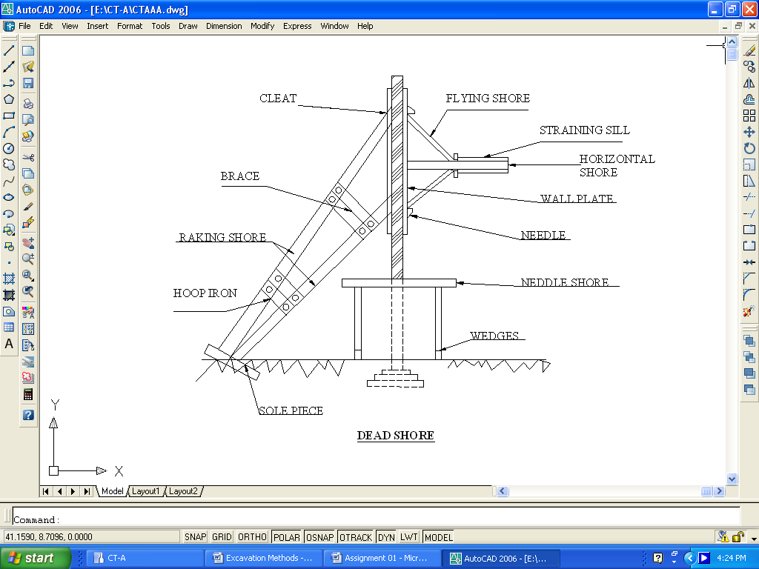

Fig.5.9. Dead shoring

Raking shoring
It is an arrangement of giving temporary support to an unsafe wall or any structure. Fig.5.10 shows the arrangement of rake shoring

Fig. 5.10 Rack shoring

Sheet piles

Sheet piles are thin piles, made of plates of concrete, timber or steel, driven into the ground for either separating members or for stopping seepage of water. They are not meant for carrying any vertical loads. They are driven into the ground with help of suitable pile driving equipments, and their height is increased while driving, by means of additions of successive installments of sheets.

Functions of sheet piles

- To enclose a site or part thereof to prevent the escape of loose subsoil, such as sand, and to safeguarded against settlement
- To retain the sides of the trenches and general excavation
- To form water tight enclosure necessary in the construction of foundation of water
- To construct retaining walls in docks, wharfs and other marine structure
- To protect river banks.
- To prevent the seepage below dams and other hydraulic structure
- To confine the soil, thereby increasing the bearing capacity of soils
- To construct coastal defence works
- To protect the foundation from scouring actions of nearby river, stream.

Sheet piles are made of the following materials,

  - Concrete sheet pile
  - Timber
  - Steel sheet
According to the site investigation the substructure work is considered as two phases.

1. Peat soil area works
2. Other soil area works

First of all clear the land and removed the trees and bushes. The site is covered by gunny bags to prevent falling dusts.

According to the building regulations, all vegetable matters must be cleared including top soil or vegetable soil from the ground where the building is to be built. Reason is as the top layer of ground contains materials which are decomposing, along with active plant life in the firm of grass, flowers, roots and shrubs. This material is easily compressible and as such it is not suitable for foundations.

In this case the top soil layer300mm depth and it is a valuable commodity. This layer is excavated and stocked in a convenient place to make a garden or to sell it.

In this substructure work, large volume of soil is to be excavated. The bulk excavation is most suitable for this construction.

Process of timber piling

- Firstly make all access to the ground.
- Penetrate the universal beam (H) irons into the ground and timber is fixed between the two adjacent H irons.
- Also, shoring is done to separate the peat soil area and other soil area.
- All timber sheets are kept at 2 feet depth above ground level.
- Keep 2 to 3 feet on all sides as foot path.

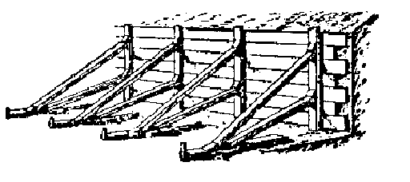

Fig.5.11 Timber piling

Method of shoring on selected area
To answer this task, I selected the My site They use ranking shoring method using H- iron bars and timbers

- Select the appropriate shoring method
Here they select the ranking shoring
- Buy the appropriate
- Timber
- H- iron bars

- Place the H-iron bars
- They hammered the H- iron bars in to soil to a depth of 3.5 feet in 900 mm center to center distance

- Place timber between the H- iron bars
- Place the prop to the shoring
They place H- iron bars props to the shoring.

Conclusion
From this assignment I got a lot enough knowledge in
- Reasons to have to do excavation
- Types of excavation, specially bulk excavation
- Excavation method of bulk excavation
- The purpose of doing shoring
- The methods of shoring
- Method of rake shoring

Task 6
Identify and state the method of construction of the foundation selected for your building.

Introduction

Site clearance and leveling:
First of all the selected land must be cleared and levelled to make the land suitable for any construction work. Trees should be cut off and removed if any and if there are any old buildings, they should be demolished as well to get a clear view of the land. If the surface of the land is not level then the land must be leveled to get a leveled surface for construction work.

Arranging scaffolding, water supply, electricity and toilets for labourers:
Providing accommodation for labourers is second most important step before the commencement of construction work. Workers, who are resided far away from the area of construction site, must be provided facilities such as water supply, electricity, and toilets with accommodation adjacent to the construction site to avoid late presence and to speed up the construction work.
The method of constructing the raft foundation
- Setting out work
Once the site has been cleared and temporary facilities have been set up the extract location ant the size of structure mast be known
- Excavation for raft foundation
Excavation was done to 5 feet’s from ground level. Balk excavation is done by JCP beckon loader in our site.
- Shoring work
Soil surface has to be excavated about 5 fetes. In our work site raft foundation has been done, according the soil infestation report. So raking shoring has been done at the work site.

- Preparation of soil leveling and compacting
Compaction should be done for prepare the smooth level surface and reduce the settlement.
- Form work for raft foundation boundary
Formwork should be done for set up the fountain bounty sides to concreting. The ply wood sheets were used for formwork.
- Apply waterproofing primer and lay polythene membrane
Foundation may receive the water percolating from adjacent ground. So Water Proofing should be done it.
- Lay 25mm 1:3 protective mortar layer
- Setting out of Columns and other members
- Reinforcement work
- Concreting

Task-07
Explore various type of form works needed for the construction of building elements and their supporting system suitable for your building construction.

Form Work
- Centering, shuttering or formwork is a sort of temporary construction provided for laying cast-in-situ concrete to required shape. A good form work should satisfy the following requirements.
- It should be strong enough to with stand all types of dead and live loads such as self weight, weight of reinforcement, weight of wet concrete, loads due to workmen, construction equipment, other incidental loads and forces caused by placement and consolidation of concrete, imposed upon it during and after casting of concrete.
- It should be rigidly constructed and efficiently propped and braced (both horizontally and vertically) so as to retain its shape without undue deflection.
- The joints in the formwork should be tight against leakage of cement grout.
- The formwork should be constructed in such a manner that it may permit the removal of various parts in desired sequence without jarring or damaging the concrete.
- The material of the formwork should be cheap, easily available and should be suitable for re-use several times
- The formwork should be set accurately to the desired line and levels and should have plain surfaces
- The formwork should be as light as possible
- The material of formwork should not warp or get distorted when exposed to sun, rain or water during concreting.
- The formwork should rest on firm base

Requirements of a good form work
- Material should be cheaply and abundantly available in local market
- Should be sufficiently rigid
- Should be easy to erect and remove
- Supports on which form work rests should be strong
- Surface of the form work should be smooth
- Joints of form work should be stiff and strong

Materials for form work

Form work can be made by using timber or steel.

- Steel form work
- High initial cost
- It can be repeatedly used for higher no. of times
- It is stronger
- It is not liable to swell, shrink, or warp
- It should be handled carefully
- Timber form work
- It is economical
- It can be made in any shape and size as per requirements

Checking items before concreting

- Dimensions of formworks
- Alignment and verticality
- Reinforcement type, cover and lap length.
- Formwork
- Electrical conduits, fan hooks
- Drainage and other pipes

Column form work

- Column form work consists of following
- Sheathing – These are vertical timber planks provided all along the perimeter of the column. Sheathing is generally nailed to yokes
- Side yokes and end yokes – The side yokes and end yokes consist of two numbers and are suitably spaced along the length of the form work. Side yokes are interconnected together through two long bolts.
- Wedges – Wedges are used to tighten various elements of the form work.

Checking column formworks

- Vertical alignment and alignment between faces
- Any possible to leakage
- Size of column
- Proper supporting
- Smoothness of inner surface of formwork

Cover blocks
- Cover blocks are used to maintain a uniform cover thickness. Main thing is the durability of concrete depends on cover thickness.
- Also, cover helps to
- Prevent those corrosive agents reaching the reinforcement.
- Protect the reinforcement in terms of time from strength loss during fire.
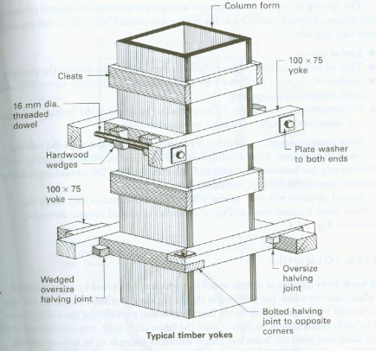

Fig.-22- Form work for column

Form work for Beams

Form work consists of following,
- Cleats – Cleats are fixed to the sides of the beams.
- Side forms or sheathing- Vertical timber planks used for side walls of the beam
- Joists or Battens – Joists support the decking. The size of the joists depend upon c/c spacing of the joists and span of the joists.
- Ledgers – Horizontal wooden pieces nailed to the cleats
- Head Tree – The whole of the beam form is supported o a head tree

Checking beam formworks

- Level of beam bottom
- Any possible to leakage
- Width and depth of beam
- Proper supporting
- Smoothness of inner surface of formwork
- If there any leakages in formwork, punch it with wet cement bags to avoid leakage.
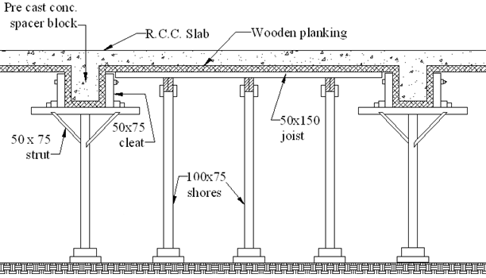
Fig.-23- Form work for Beam & slab

Task 08
Explain the major reinforced concrete members of your building, their reinforcement arrangement (include important checks) and methods of constructions (steps should be clearly demonstrated)
REINFORCEMENT
The material which can be used as reinforcement in R.C.C work should have the following characteristics
- It should be able to develop perfect bond with concrete.
- Its co-efficient of thermal expansion should be nearly same as that of concrete.
- It should have high tensile strength.
- Concrete should not produce any harmful effect on the embedded material.
- It should be easy to cut, bend, bind or weld.
- It should be easily available.
REINFORCE CONCRETE
- Though strong in compression, concrete is extremely weak in tension. Its resistance to tension is so low that plain concrete can only be used where the member is in pure compression. Steel on the other hand is equally strong in compression and tension. Therefore steel combined with concrete. Such as a combination is called reinforce concrete.
ADVANCETAGES OF REINFORCED CONCRETE
- It is economical in ultimate cost.
- It is almost impermeable to moisture.
- The cost of maintenance of a reinforced concrete structure is almost nil.
- The materials used in the reinforced concrete construction are easily obtainable.
- Its monolithic character gives much rigidity to the structure.
- It is durable and fire- resisting. It does not rot or decay and is not attacked by termites.

Main components of reinforcement
- Concrete
- Reinforcement (steel)
Concrete
Concrete is a soled hard material, which is consists of cement, fine aggregate (sand < 0.5mm), cost aggregate (material > 0.5), water, admixture.
The concrete strength, durability other characteristics of concrete depend on the properties of the mixture, method of compaction, grate of the concrete.
PROPERTIES OF CONCRETE
- Strength - The concrete must be strong enough to with stand without injury all the imposed stresses with the required factor of safety.
- Durability - It is the property of concrete by virtue of which it is capable of resisting its disintegration and decay. which may be caused due to:
- Use of unsound cement.
- Use of less durable aggregate.
- Entry of harmful gases and salts through the pores and voids preset in the concrete
- Freezing and thawing of water sucked through the cracks or crevices by capillary action.
- Expansion and contraction resulting from temperature changes and alternate drying and wetting.
- Workability - It is simplest from a concrete is said to be workable if it can be easily mixed, handled, transported, placed in position and compacted.
- Moldable - Can be cast and any shape.
- Economical - Reasonable price.

GRADES OFCONCRETE
Seven grades of concrete were specified as M 100, M 150, M 200, M 250, M 300, M 350 and M 400. In the designation of the mix letter M represented the mix. Represented the work cube compressive strength of 15cm cubes at 28 days expressed in
Grades of concrete
M 10
M 15
M 20
M 25
M 30
M 35
M 40
10
15
20
25
30
35
40

Strength at 28 days in N/mm²
Grade of concrete

- These grate concrete mixtures used in my site
- Grate 15 & 20 – for screed concrete

- Grate 25 - for heavily load columns
- Grate 30 & 35 – for the retain structures

Admixtures
- In our site admixtures are used in this purpose 25c°
- Concrete tests
  - Concrete strength testing
  - The workability of concrete can be measured by one of the following three tests
    - Slum test
    - Compaction factor test
    - Vee-bee test

  - Cube test

- In our site done slum test to test the workability
- The workability of the mix is determined by the slump test.
- The amount of the slump, (in length) is the measure of the `concrete’ workability.
- The more the slump, the higher the workability
- The slump can be controlled change in any one or all of following:
  - Gradation of aggregates,
  - Proportion of aggregates, or
  - Moisture content.
Compaction
Consolidation of concrete should proceed immediately after placing. The concrete mss should be consolidated or compacted till the cream of the cement starts appearing on the surface. Over- compaction may lead to segregation of concrete while under- compaction may leave air- voids in concrete. Consolidation done by hand or by mechanical device.
It is important to remove this entrapped air (voids) for the following reason.
    - Voids reduce strength of concrete
    - Voids increase the permeability, which is turns reduce the durability
    - Voids produce honey combing at concrete
Methods of compaction
      - Hand compaction
-manual compaction may be done by Roding, temping or hammering
      - Mechanical compaction
-mechanical compaction is done by the use of vibrators.
Vibratos are four types:
- Internal vibrators (immersion type)
- External vibrators
- Surface vibrators
- Vibrating table
- In our site manual and mechanical compaction were used.
Curing of concrete
Curing is process of keeping the set concrete continuously. Mainly two type curing methods are used. There are chemical curing and water curing.

Column
Introduction
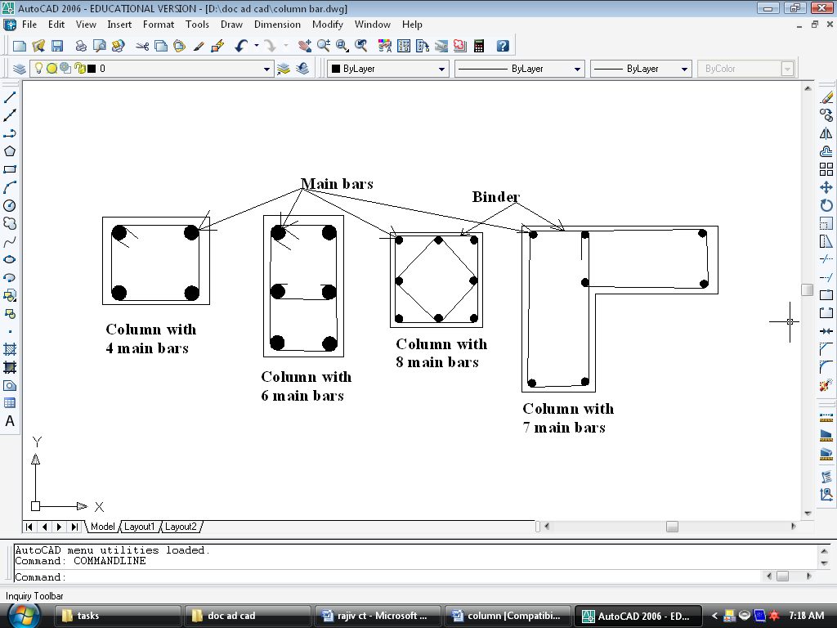
- A structural member subjected principally to compressive stresses. Concrete filled steal as structure columns supporting vertical concentric compression load. This carries the beam and floor loading to the Foundation. The shapes of the columns are square, rectangular, circle, and L shape.

Figure -24- Column main bar arrangement details
- They have used tor steel as main bars and mild steel for the shear link purpose. According to BS 8110 they provide 25mm cover from the reinforcements to protect it from fire and corrosion.
Column reinforcement method
- In column construction first we have to arrange the reinforcement system. Reinforcement content With Tor or mid steel and binding weirs.
- Setting out: - Knowing in the correct passion of the column and beam.
- The suitable form work for column length and width of form work depends on size of column
- Reinforcement
- Form work: - we have to put the concrete in to the form work but in column constriction concrete not finishing on time in one time only fill the 4-5 ft not its difficult to compaction
- Compaction using with vibration
- Concreting: - now the concrete mixture at the necessary ratio (G25) may be placed in to the box and reinforce the mixture by the vibrating machine.
- Remove the form work after the 24 hrs of the concreting work.
- Leave the column for curing.
- This is counting for finishing level of column
In my site column layout
In my site column bar details
For ex: 6 T 16 105 (In this case we doesn’t need a c/c distance for tor steel)
6 = Bar numbers
T = Tor steel
16 = Bar diameter
105 = Bar mark
For ex: R 10 102 150 (In my drawings the bar marks were not indicated.)
R = Mild steel
10 = Bar diameter
102 = Bar mark
150 = Center to center distance

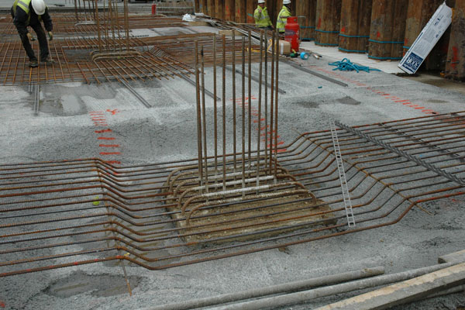

Figure -25- Column reinforcement at the site

Slap
Introduction
Reinforced concrete slab
A reinforced concrete slab will behave in exactly the same manner as. The designer will analyze the loadings. Bending movement shear forces and reinforcement requirement requirements on a slab strip 1.000m wide. In practice the reinforcement will be fabricated to form a continuous mat. For light loadings a mat of welded fabric could be used.
Slabs-general use.
Slabs are horizontal members of the building. Slabs gives a strucral view to the building.slabs are placed on the beams. After the slab is built, then only the partition works starts. So here slabs acts as a stand to hold the live loads as well as some dead loads too.
Slab Reinforcement
When rebar arrange for floor, main bars and distribution bars should be considered. Longest span bars are distribution bars. In bottom, main bars should be below the distribution bars. In top, main bars should be above the distribution bars. Grade 25 mixture is used for this reinforcement. 01mm cover block was adopted above the form work.
Necessary pipes have to be providing at the proper places for electrical wiring and plumping purposes. For the fitting of electrical lights, fans, and any other fitting if necessary places for that should be reserved.

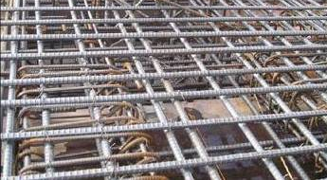

Figure -26- reinforcement arrangements for slab

Figure -27- reinforcement arrangements for slab

Conclusion
When we consider this site, they have used beam and slab floors. Beam and Slab floors are easier to construct. Because beam and slab connection is easy to construct.

Task-09

Write the method statement for the construction of brick walls at your selected site

Brick work is mainly used for construction of walls the building construction by the bedding and jointing of bricks into established bonding arrangements. A wall is a continuous, usually vertical structure of brick, stone, concrete, timber or metal, thin in proportion to its length and height. It is encloses and protects the building or serves to divide buildings into rooms.
The Material used in brick masonry are

- Bricks
- Mortar

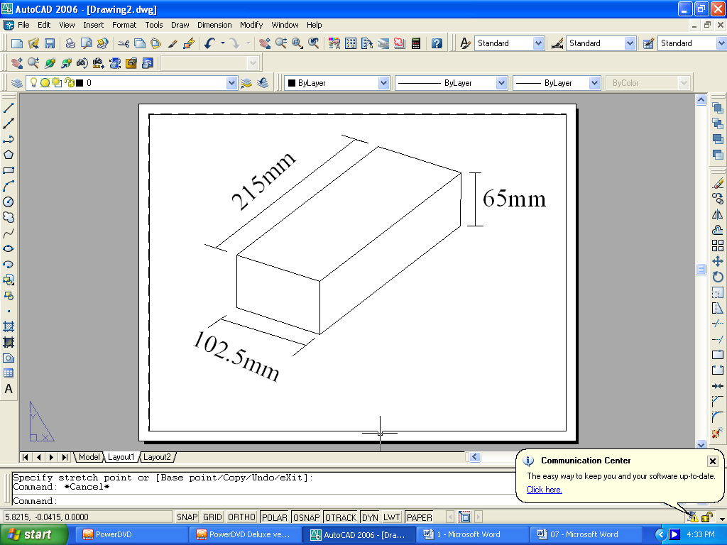
Bricks

Fig.-28- Size of brick

The standard brick size is 215mm×102.5mm× 65mm, and to avoid confusion when rendering to brick arrangements the parts of the brick are given different names. Some bricks have no frogs or indents, some have two, and others may have holes of various shapes passing through them from top to underside. The size of the brick is such that, with allowance for jointing, two header faces equal one stretcher face and three course height also equal one stretcher face.

Stretcher

Header

Fig -29- Faces of brick

Two type of bricks are used in masonry work

- Traditional bricks
- Modular bricks

Mortar

- This is the main binding material which is used in brick masonry.
- Mainly cement is used for this purpose
- Mortar which has been used in olden days are far more durable than the mortar which is been using presently.
- After hardening the mortar offers a great resistance to weather

The strength of brick masonry depend on,

- Quality of brick
- Strength of brick
- Mixture of mortar
- Method of bond
- Size and shape of construction
- Nature of workman ship and supervision

Functional requirements of brick work

- Partitions
- Sound insulation
- Heat insulation
- Fire resistance
- Strength and stable
- Durability
- Feasibility

Bonds in brick masonry
- English bond
- Stretcher bond
- Header bond
- Flemish bond
- Herringbone bond

English bond

Fig.-30- English bond

Here the bricks are laid in alternate course of headers and stretches. It is an important type of bond which is most commonly used in practice. It is considered to be more compact and stronger.

Stretcher bond

Fig.-31- Stretcher bond

Here all the bricks are laid in stretcher courses. This type is useful for one brick partition wall since there are no headers.

Header bond

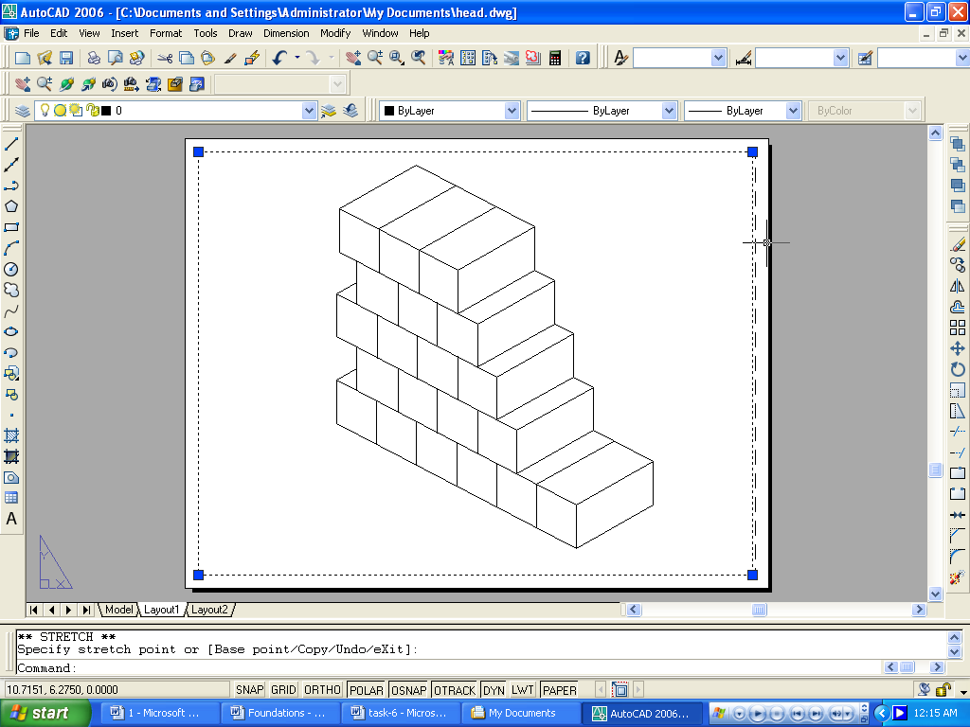

Fig.-32- Header bond

Here all the bricks are laid in header courses. There are no stretchers

Flemish bond
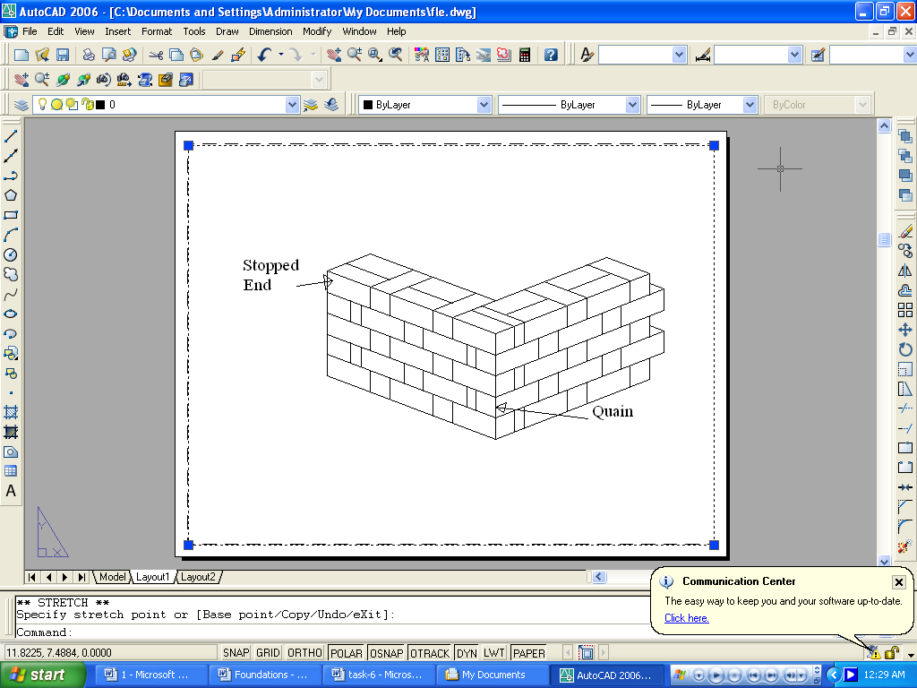

Fig.-32- Flemish bond

Here in each individual course, alternate headers and stretchers are laid as shown in figure. These bonds have good appearance. But good workmanship and supervision are required. These bonds are also economical since a large percentage of brick-bets are used.

Herringbone bond

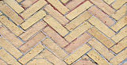

Fig.-33- Herringbone bond

When bricks are laid on alternating angles, it is called a Herringbone. This is primarily a decorative style, more often used for paving or fireplace reflectors than for walls. It is generally considered unsuitable for load-bearing structures, but may be found as infill in traditional timber framed buildings. This style is also sometimes called by its Latin name: Opus spectrum

Method of construction of the English bond

- Bricks should be thoroughly soaked in clear water before using it for a suitable period
- Bricks are laid in a full bed of mortar and it should be leveled without any slopes in it
- All the courses should be truly horizontal and all the vertical joints should be truly vertical
- Joints should be filled with mortar without any cavity in between it
- The first two courses should be laid normally
- Queen closer should be placed after the 1st header
- Upper courses should be laid by starting through the end. That means the ends are laid 1st in the 3rd, 4th and 5th course before the inner surface is laid
- These outer surfaces should be perpendicular
- Then a line is stretched from A to B and through that the other bricks are laid.
- Iron fixtures should be embedded in cement mortar or in cement concrete
- Expansion joints should be provided in mortar
- The walls should be truly vertical
- English bond is a very advantages bond because of its low cost and high strength. Therefore this is used in many constructions and easier to construct too.
- This simple but strong bond has been used in used in the visited site and its method statement has been identified.

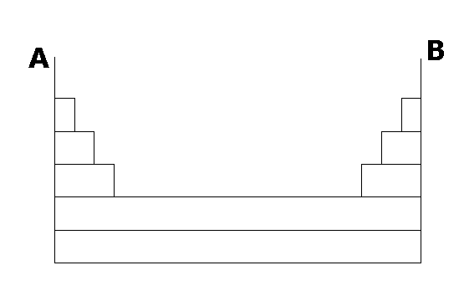

Fig. -34- The method of brick laying

Advantage of brick masonry

- Bricks are manufactured in uniform size and shape. Hence, dressing of bricks is not required.
- Bricks are lighter in weight and therefore, easy to handle. They save much in construction.
- Bricks can be laid in any pattern due to their uniform shape and size. They give better uniformity in construction and thickness.
- Less skill is required in laying.
- Mortar required is less because uniform size of bricks.
- Walls of any thickness can be constructed such as partition wall, panel, and curtain walls.
- Bricks are fire resistant. They have thermal insulation. Building are cooler in summer.

Disadvantage of Brick masonry

- Strength is less.
- Less water tight. They absorb moisture from atmosphere. Hence, they require plastering. Hence, extra cost.

TASK-10
Describe the method of wall finishing that you recommend for your building.
Drywall is the building material used to create the walls of your home. It comes in standard 4x8 foot sheets. It also comes in various thickness, from ¼" to 5/8". But probably the standard thickness is ½" which we used in our project of putting drywall over a framed out storage area in our garage.
- Measure the length of the wall. In our case, our first wall was 48" long. When hanging drywall you want to hang it horizontally so that you have the least number of seams that you have to tape and bed in the wall. Also, you want to avoid lining up seams of each drywall piece as you go hang each row.
- Always hang drywall from the ceiling down. This way if you have to put in a narrow piece at the bottom of a wall for whatever reason, it won't stand out as much as if it were eye level or above. This way the wall will look better and will be straighter.
- Take your measurement, and mark 48" on the drywall. The studs of our wall are 16" on center so we need to mark the drywall for that as well, that way we'll know exactly where to put a nail or screw so that it will hold it to the stud.
- After you've marked the drywall for length and studs, take a T-square, or a four foot level, something that is long enough to give you a straight edge across the 4' width of the drywall. Use a pencil to mark that line across the sheet of drywall.
- Take a utility knife and score the drywall along the length line you've marked, in our case, at 48". (Since we're hanging a piece of drywall on a wall that is less than the 8 feet long standard piece of drywall, we are going to have to break the drywall to the correct length.)
- Once you have the length line scored, go around to the back of the drywall and put your knee on the line where the drywall is scored. Then crisply pull the drywall towards you. This will break the drywall in half. Again take the utility knife and cut the paper backing on the drywall.
- After this is done, you may notice that the edges of the drywall are a little rough. That's OK, take a drywall shaver tool and rub it along the edges to smooth them out for a nice clean edge.
- Once you've got your edges smoothed out, you're ready to hang the drywall. Use a hammer and drywall nails to attach the drywall to the studs. For the top piece, make sure it is flush with the ceiling and you're ready to nail. When you hammer in the nail, you want to hammer the nail so that it's just recessed a little bit in the paper. In other words, you want to hammer in the nail just enough to create a little dimple. If you hammer the nail too deep, you'll break the core of the drywall and it will lose its strength.



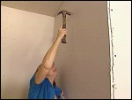

If you don't feel confident with a hammer, you can buy or rent a Duraspin drywall screw gun. The great thing about this tool is that it has a depth gauge so you can set the depth of your screw so that it will create a perfect dimple every time and not damage the drywall.
Taping and Bedding the Drywall
Taping and bedding is the method for smoothing out the nail marks and seams to give you a seamless, smooth looking wall.
- First, you need to buy some joint compound (available at any hardware or home center) and a 4", 8" and 10" blade.
- Take the 4" blade, and use it to apply joint compound over the dimples left by the nails or screws in the drywall. Be sure and scrape away any excess.
- Take the 4" blade and float in or spread about a ¼" of joint compound over the seams. Make sure you have a nice even layering.
- Take some drywall tape, and spread it evenly over the joint compound that's covering the drywall seams. The joint compound will hold the tape in place.
- Tear the tape off when you reach the end of the seam.
- Take the drywall 4" blade and while holding the tape down with hand, smooth out both the tape and the joint compound to make sure you don't have any bubbles in the seams.
- After this first coat is dry, lightly sand it. You don't want to sand too hard because you don't want to tear the paper.
- Apply a second coat of joint compound over the tape using an eight inch blade. Let that dry overnight and then sand it again. Then apply your third and final coat using a 10" blade.




As you can see you're using larger blades each day. The reason for that is that you want to feather or spread out the joint compound and extend it so that it blends in with the rest of the wall.
After the third coat is dry, sand it once again to get rid of any imperfections. After this is done, you're ready to put texture on the drywall and then it will start looking like a "real" wall.

TASK-11
Identify all the building elements to be water proofed. Propose a method of waterproofing for the foundation of your building. you shall visit a waterproofing company or a building site where waterproofing is been done, to collect information.

Water proofing
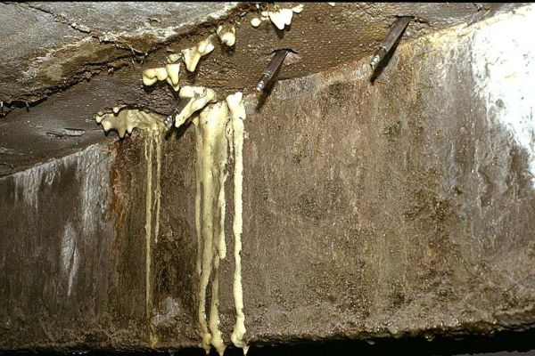

The prevention of water penetration through the concrete and the columns are called as water proofing.
A building/structure needs waterproofing as concrete itself will never be so perfectly placed as to be watertight on its own. The conventional system of waterproofing involves 'membranes'. This relies on the application of one or more layers of membrane (available in various types of materials: e.g. bitumen, silicate, PVC, HDPE, etc) that act as a barrier between the water and the building structure, preventing water ingress.

General description
Water proofing are essential requirements of a building is that it should be dry Dampness in building may occur due to bad design, faulty construction and use of poor quality of materials.
Dampness not only affects the life of the building adversely, but also cerates unhygienic condition for the occupants. Hence, treatment to check dampness is considered to be one of the important items of work in the construction of a building.
The Treatment given to prevent leakage of water from roof is generally termed as water proofing, where as this treatment given to keep the walls, floors and basement dry is termed as water– proofing.
Method of water- proofing
- Membrane damp - proofing.
- Integral damp – proofing.
- Surface treatment.
- Guniting.
- Cavity wall construction.
Membrane damp proofing
- This consists in providing layer or membrane of water repellent material between the source of dampness and the part of the structure adjacent to it. May be provided horizontally or vertically in floors, walls, etc.
Integral damp-proofing
- This consists in adding certain water-proofing compounds with the concrete mix to increase its impermeability. The quantity of water- proofing compound to be added to cement depends upon the manufacturers recommendations. In general, one gutter proofing compound is added with one bag of cement to render the mortar or concrete water proof.
Surface treatment
Surface treatment is applied to filling up the pores of the surfaces subjected to dampness. The use of water repellent metallic soaps as calcium and aluminum oblates and separates is much effective is protecting the building toilet against ravage of heavy rain. Bituminous solution cement coating transparent coating paint and varnishes are some other material use for surface treatment.

Materials used for water proofing

An effective water proofing material should have the following properties:
- It should be impervious.
- It should be strong and durable.
- It should be dimensionally stable.
- It should be free from deliquescent salt like sulphates, chlorides

In the site water proofing was carried out in following places and components.
- Toilets and bathroom areas
- Basement slab
- Retaining wall
- Sump
- Lift fit

One of the essential requirements of a building may occur due to bad design faulty construction and use of poor quality of materials. Dampness mot only affects the life of the building
adversely, but also creates unhygienic conditions for the occupants. Hence, treatment to check dampness is considered to be one of the important items of work in the construction of a building .The treatment given to prevent leakage of water from roof is generally termed as water –proofing, whereas the treatment given to keep the walls, floor and basement dry is termed as damp-proofing.
Following methods are generally adopted to prevent the defect of dampness in a structure.
1. Membrane damp-proofing
2. Integral damp-proofing
3 .Surface treatment
4. Gunning
5. Cavity wall construction
Basic Methods of Foundation Waterproofing
It is absolutely necessary to waterproof the foundation of your home. Foundation waterproofing is a critical step in maintaining your home’s value and an important measure for preventing very serious damage. Usually done by professionals, foundation waterproofing is generally not recommended as a do-it-yourself project. Your home is likely your biggest investment, and foundation waterproofing is imperative in order to protect that investment. Ideally, foundation waterproofing takes place as the home is being built, but years of settling and water leakage or negligence on the part of the contractors often leaves the home’s foundation unprotected.One short-term waterproofing method is the use of black tar for foundation waterproofing, but this is certainly not recommended. Keep in mind that this is a very short-lasting method that will dry out, crack and let water seep back in within five to eight years. In professional terms, tar is used as a damp-proofing method rather than a waterproofing method. If you do choose to attempt do-it-yourself foundation waterproofing, it is recommended that you use rubberized liquid membrane, which is basically the same material that automobile tires are made of. The liquid membrane is quick drying, inexpensive and generally easy to apply. It can be applied with a roller, sprayer or trowel. Be aware that by using this method, you run the risk of inconsistently applying the membrane. Pay careful attention to ensure it is properly applied. Again, foundation waterproofing is generally left to the professionals. There are materials and methods available for people who wish to do it themselves, but it’s a good idea to do some research first as it is important to get the job done right.

Task-12

Demonstrate the timber work required for your building construction and their associated connection

Timber
Timber is one of the oldest structural materials used by man with the advent of many building materials like steel and concrete and with ht fast declining recourses of wood in the country the use of timber for constructional purpose has declined. The cost of timber construction has also gone considerable.
The panel industry uses wood veneer and residues to produce ply wood, new products. Such as fiber board, and other materials generally used in building construction new wood products are also being developed, using laminated wood strips to create beams an joints.

Properties of timber
- Colour
- Durability
- Hardness
- Density
- Grain
- Texture

Colour
- the colour of wood may be uniform mottled or streaked the colour my very from cramy white to jet black through varing shades of grey yellow, plank, red, brown, and purple. In general a darker colour in wood. Indicates greater durability because of the present of natural toxic substances.
Durability
- Woods naturally a very durable sub stance. The most important of the organizing attacking wood are the fungi that cause so called dry rot, which actually occurs only when the wood is damp wood may be preserved by protecting is chemically against deterioration. The most important method of treatment has long been impregnation with creosote or zinc chloride. This method is still one of the best, although a number of newer chemicals , notably several containg copper compounds, have coating ,applied by brushing, spraying surface application yield little penetration under attack by insect, fungi, or borers.
Hardness
- Woods are classified as soft wood or hand wood, depending on the tree from which they come woods from broad – leaved trees are called hard woods, and woods from coniferous tree are called soft woods, regardless of their actual hardness.

Density
- The principal physical properties of wood are strength, hardness, stiffness, and density. Density is generally an indication of the mechanical properties, in as mush as does wood are usually hard and strong.

Grain
- The typical marking, called grain, that are found on all types of natural are due to the structure of the wood. Wood consists essentially of fine cellular ducts or tubes, which carry water and dissolved minerals from the roots to the leaves and which are thus arranged more or less vertically with in the trunk.

Uses of timber
- Timber is for the following purposes:
- For construction purpose : such as building construction doors, windows, ventilators, house posts, beams, trusses, rafters, bridges, piles, poles, arches, flooring, ceiling, partition walls etc.
- For railways: for sleepers, coaches and wagons.
- For furniture : for tables, chairs ,cabinets
- For form work: for centering for R.C.C works.

Advantage of timber construction

- It can be easily sawn and cut.
- It can be easily joined with ordinary carpentry tools.
- It can be used both for load bearing and non load bearing structure.
- Timber is easily available and can be easily transported.
- If properly seasoned and preserved it is quite durable.
- It has good re- sale value.

Disadvantage

- If not properly seasoned it is likely to crack or warp.
- If not properly preserved it is likely to decay.
- It requires regular maintenance.
- It is not fire resistant.
- If not locally available it proves to be costly

Testing of timber
The following are the most commonly studied properties of wood.
- Moisture content
- Specific gravity
- Shrinkage and swelling
- Compressive strength
- Tensile strength

Timber joints
Many different types of timber joints are used with in the construction industry. They can be classified as follow:-
- Lengthening joints
- Widening joints
- Angle joints
- Bearing joints
- Oblique shouldered joints
- Framed joints

Lengthening joints
These joints are used to increase on to extend the length of a member. (These can be classified as:-Lapped joint, Fishing joint, Scarfing joint, Tabling joint)

Widening or side joints
These joints are used to extend the width of the planks or boards they are used for laying planks in floors or in batted doors.

Bearing joints
These are joints in which two members are joined at right angle to each other. These joints are made sufficiently strong.

Oblique shouldered joints
This category of timber joints mostly used in the construction of timber roofing trusses where various members have to be joined at acute or obtuse angle. (These can be classified as: - Bindle joints, Oblique tenon joint, Birds smooth joints, Chase mortise joints)

Angle joints
These joints are used to connect members at end at right angle.

Framing joints
These joints are employed for framing of doors, windows, partition walls. These joints are also bearing joints but they are not supposed to carry as much force as beading joints do.(These can be classified as: - Joint of bottom rail, Joint of top rail, Joint of lock rail)

Most commonly used timber joint in building construction
Lapped joint: - This joint is formed by putting the two wooden pieces one over the other, for a short distance and then fastening them together with bolts.

Conclusion
Timber is the most important structure material. Wood is potentially very durable. But, being organic is effected by climate and biological factors and in the tropics the effects can be severs.
In my site used for such as building construction doors, windows, ventilators, house posts, beams, trusses, poles, arches, flooring, ceiling, partition walls etc.

